Part I: Short Answer
- Write ‘True’ or ‘False’ for the statements. Answer:
  - False
  - True
  - False
  - True

- Correct answer:
  - A
  - C
  - C

Test 1 | 0
Test 2 | Class B
Test 3 | class A  class A  class A
Test 4 | Compile error
  - The expected output in the corresponding fields for each Test class:

Polymorphism method | Answer (Binding Type)
Method Overriding | Late binding
Method Overloading | Early binding
Private methods | Early binding
Final methods | Early binding
  - Fill in the corresponding fields specifying the type of binding whether its Early binding or Late binding.

Part II: Skill Questions
- Draw a UML class diagram consisting of three classes: Curriculum, Course, and Lecture.
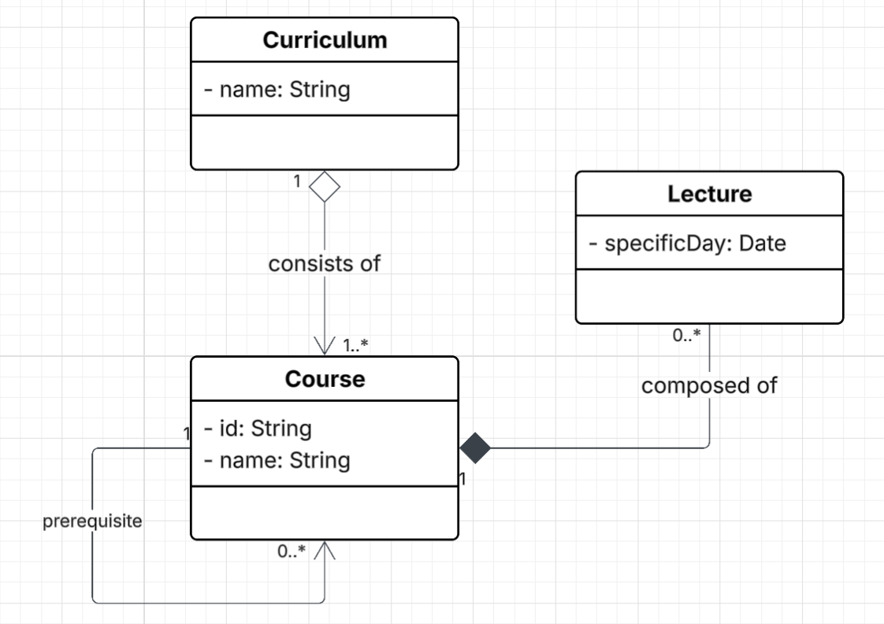
- Draw a sequence diagram for the method register()
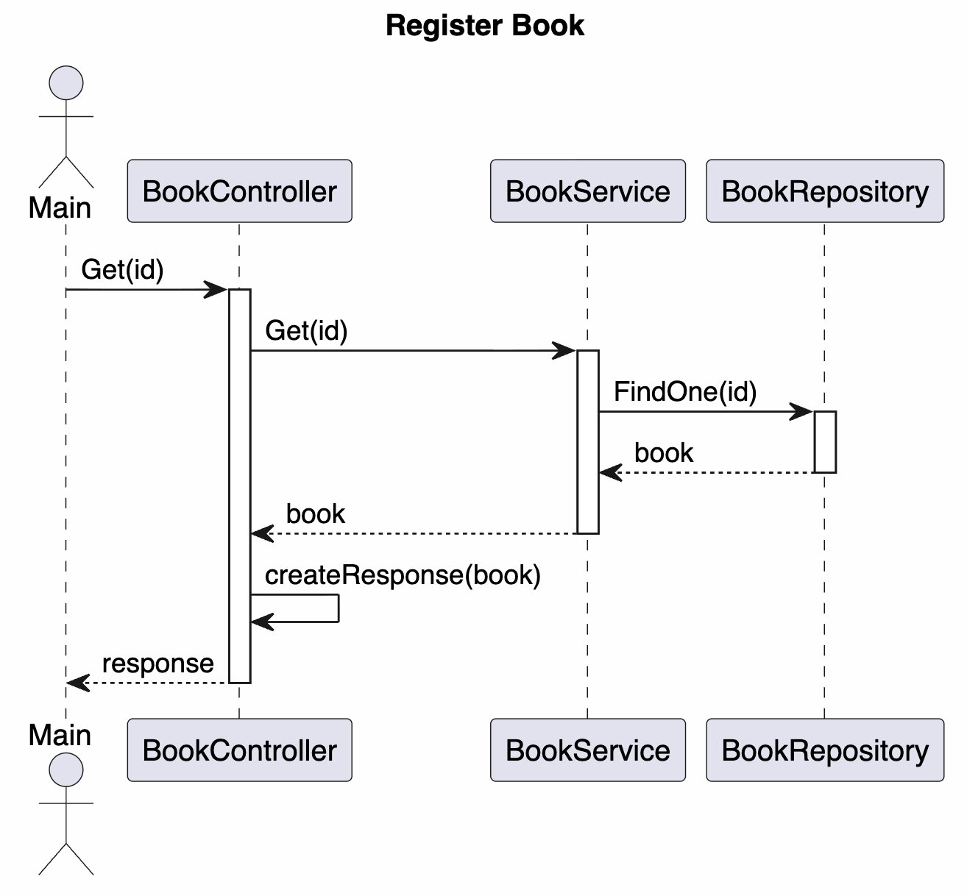

- Rectangle:
  - As shown, there is a compile error, explain why an error is occurring.
- There is a complile error, because: In Java, when you overload constructors, each constructor must have a unique signature. A signature is defined by the number, order, and types of the parameters. Both constructors in your Rectangle class have the exact same signature:
- Constructor 1: Rectangle(double len, double width) => Signature: (double, double)
- Constructor 2: Rectangle(double width, double diag) => Signature: (double, double)

  - Using the Factory Pattern here adheres to two main SOLID principles:
    - First, Single Responsibility Principle (SRP). It separates object creation from object behavior. The Rectangle class should only focus on rectangle properties (like area). The complex logic of how to build a rectangle (calculating sides from diagonals) is moved to the Factory.
    - Second, Open/Closed Principle (OCP). Software should be open for extension but closed for modification. If you want to add a new way to create a rectangle (e.g., using Area and Width), you simply add a new factory method. You don't have to modify the existing constructors or risk breaking the current code.
  - Rewrite the code for Rectangle class:
public class Rectangle {
private double length, width, diagonal;
private Rectangle(double length, double width, double diagonal) {
this.length = length;
this.width = width;
this.diagonal = diagonal;
}
public static Rectangle fromSides(double len, double width) {
double diag = Math.sqrt(len * len + width * width);
return new Rectangle(len, width, diag);
}
public static Rectangle fromDiagonal(double width, double diag) {
double len = Math.sqrt(diag * diag - width * width);
return new Rectangle(len, width, diag);
}
public double computeArea() {
return length * width;
}
}

- Owner | Building | Apartments classes:
import java.util.ArrayList;
import java.util.List;
class Owner {
private String name;
private String telNumber;
private List<Building> buildings;
public Owner(String name, String telNumber) {
this.name = name;
this.telNumber = telNumber;
this.buildings = new ArrayList<>();
}
public void addBuilding(Building building) {
buildings.add(building);
}
public double getRent() {
double totalRent = 0;
for (Building b : buildings) {
totalRent += b.getRent();
}
return totalRent;
}
}

import java.util.ArrayList;
import java.util.List;
class Building {
private String buildingNumber;
private List<Apartments> apartments;
public Building(String buildingNumber) {
this.buildingNumber = buildingNumber;
this.apartments = new ArrayList<>();
}
public void addApartment(Apartments apartment) {
apartments.add(apartment);
}
public double getRent() {
double totalBuildingRent = 0;
for (Apartments apt : apartments) {
totalBuildingRent += apt.getRent();
}
return totalBuildingRent;
}
}

import java.util.*;
class Apartments {
private double rent;
public Apartments(double rent) {
this.rent = rent;
}
public double getRent() {
return rent;
}
}

- Source code:
package Prob5;
import java.time.LocalDate;
import java.time.Period;
public abstract class Service {
private int Daily_Price;
private LocalDate Date_Subscribed;
public void setDailyPrice(int dailyPrice) {
this.Daily_Price = dailyPrice;
}
public int getDailyPrice() {
return Daily_Price;
}
public void setDateSubscribed(LocalDate dateSubscribed) {
this.Date_Subscribed = dateSubscribed;
}
public LocalDate getDateSubscribed() {
return Date_Subscribed;
}
public int dateDifference() {
LocalDate now = LocalDate.now();
LocalDate subDate = Date_Subscribed;
Period period = Period.between(subDate, now);
int diff;
int Month_diff = period.getMonths();
int Day_diff = period.getDays();
if (Month_diff != 0) {
diff = (Month_diff * 30) + Day_diff;
} else {
diff = Day_diff;
}
return diff;
}
public abstract int calcFee();
}

package Prob5;
public class Daily extends Service {
@Override
public int calcFee() {
return getDailyPrice() * dateDifference();
}
}

package Prob5;
public class Monthly extends Service {
@Override
public int calcFee() {
return getDailyPrice() * 30;
}
}

package Prob5;
import java.util.Vector;
public class Customer {
private String Name;
private int ID;
private Vector<Service> Services = new Vector<>();
public Customer(String name, int id) {
this.Name = name;
this.ID = id;
}
public void addService(Service service) {
Services.add(service);
}
public void removeService(Service service) {
Services.remove(service);
}
public int totalFee() {
int total = 0;
for (Service s : Services) {
total += s.calcFee();
}
return total;
}
}

- Bonus Question (A)
- @Override
public int calcFee() {
int totalDays = dateDifference();
return totalDays * getDailyPrice();
}

- Bonus Question (B)

In an ancient text, one reads the following: Know that by which all this is known.

  - What does this expression mean?
- It refers to Pure Consciousness or the Self. It means focusing on the source of awareness (the knower) rather than just the information being learned (the known).
  - What is it saying?
- It suggests that consciousness is the foundation of all experience.
  - Is it some kind of SCI point?
- Yes. It reflects the core SCI principle: "Knowledge is structured in consciousness."
  - Does this expression illuminate any aspect of the software engineering discipline discussed in class? Explain.
- Yes. It highlights the importance of Fundamental Principles over specific technologies.
Explanation: In Software Engineering, languages and frameworks (the "known") change constantly. However, the underlying logic, data structures, and design principles like SOLID (the "by which" we create software) remain constant. By mastering these core foundations, a developer can easily understand and adapt to any new technical challenge.

Script to draw sequence diagrams:
II.2 -------------------------- Start --------------------------
@startuml
title Register Book
actor Main

participant BookController
participant BookService
participant BookRepository

Main -> BookController : Get(id)
activate BookController

BookController -> BookService : Get(id)
activate BookService

BookService -> BookRepository : FindOne(id)
activate BookRepository

BookRepository --> BookService : book
deactivate BookRepository

BookService --> BookController : book
deactivate BookService

BookController -> BookController : createResponse(book)
BookController --> Main : response
deactivate BookController

@enduml
II.2 -------------------------- End --------------------------

